Giving name to test plan as XML assertion Test Plan

Right click on the test plan and click on add then click on Assertion ,then select xml Assertion

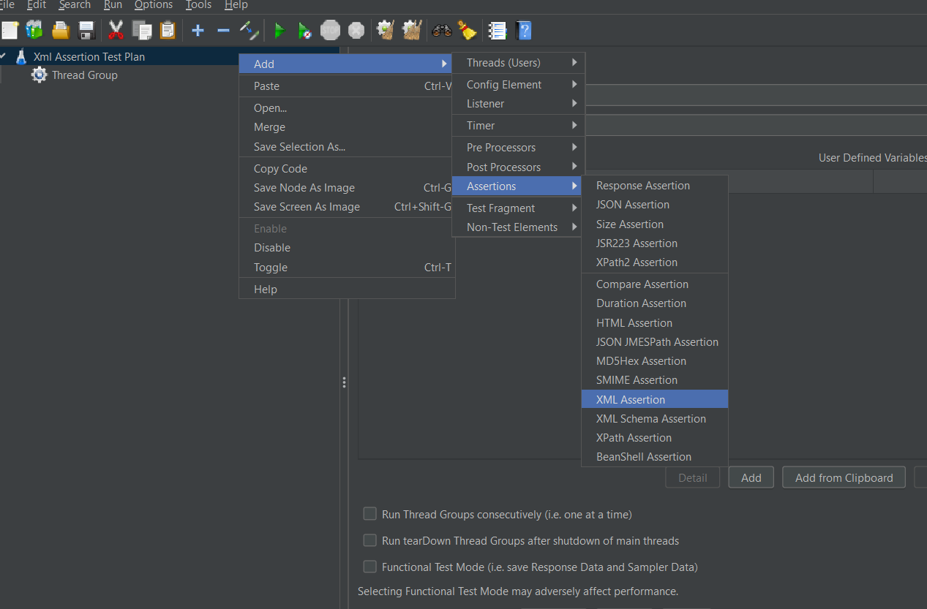

Then Right click on Test plan then click on add,click on listener then select view result tree

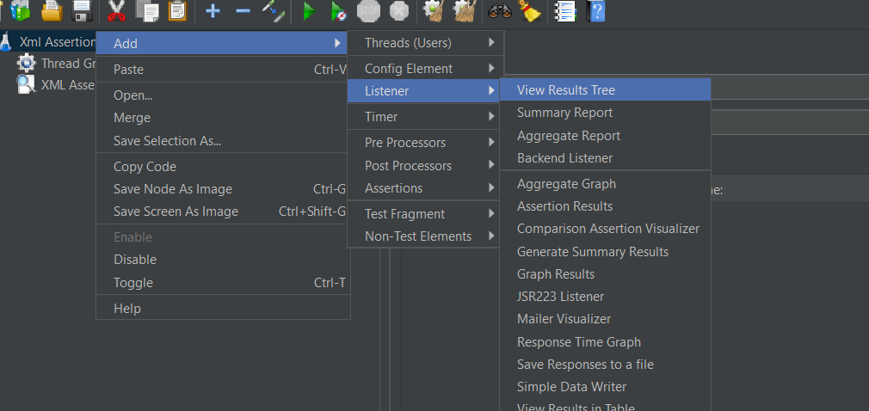

Then Right click on test plan ,click on add,listener then select Assertion Result to view the assertion result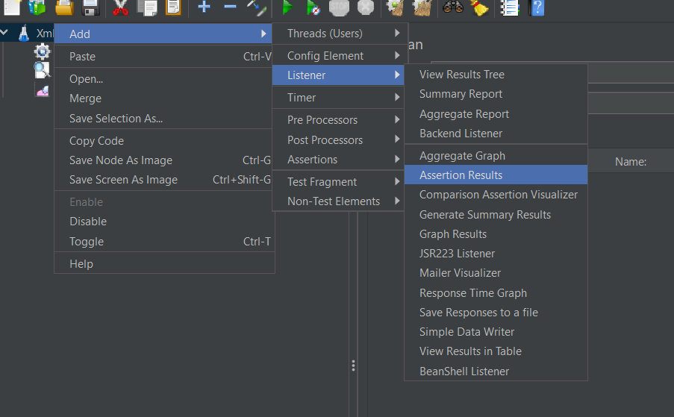

Right click on Thread group then click on add then click on sampler then select HTTP Request

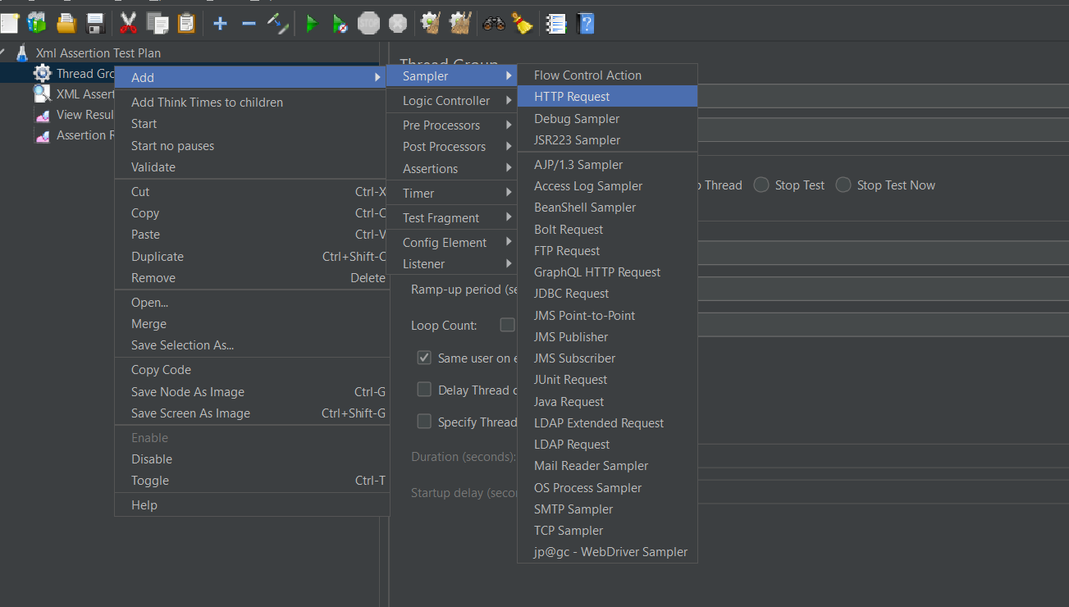

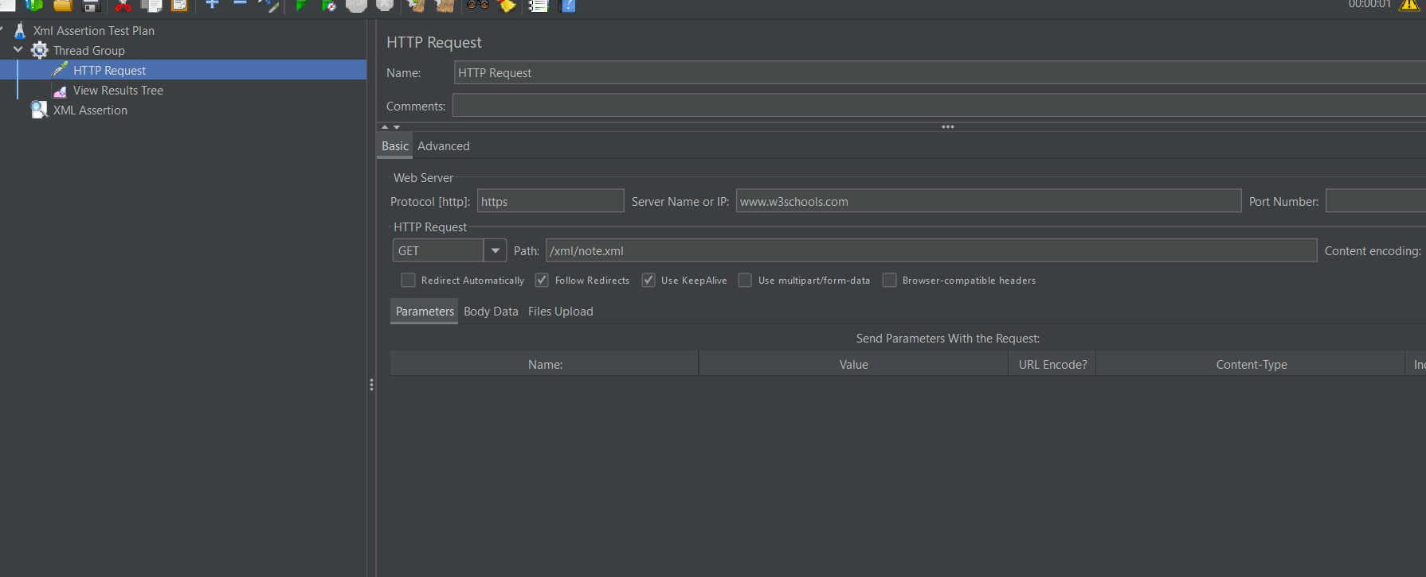

Click on run button

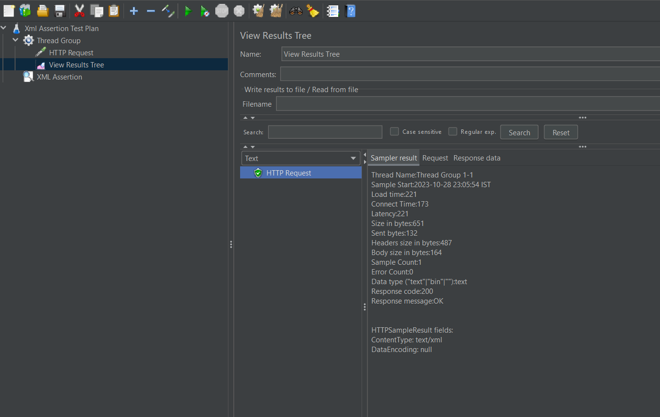

XML Schema Assertions

It just check whether the xml Assertion has schema or not

First convert the given xml file in xml schema file and save as .xsd in notepad and save the file in Jmeter example folder

And give the path of the file in xml schema Assertion.

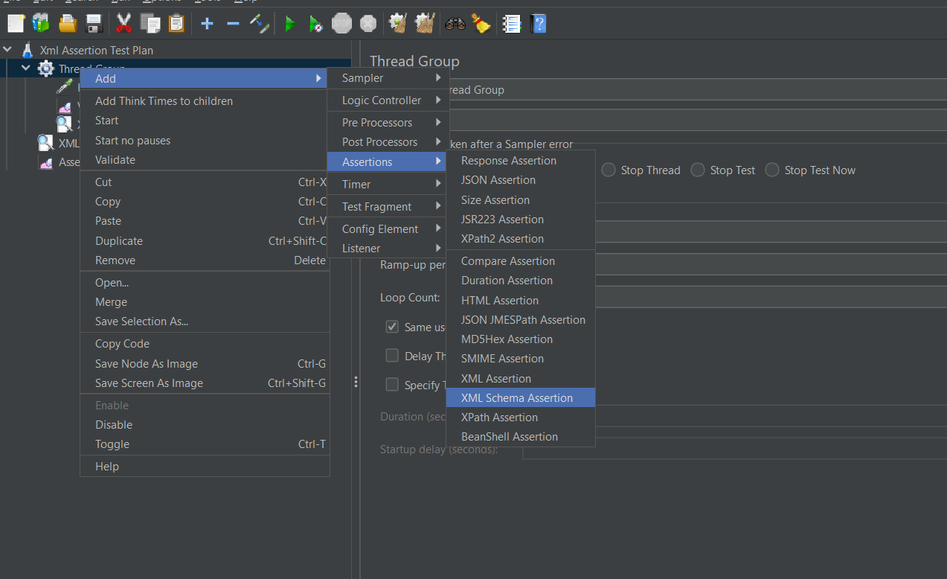

Converting xml into xml schema in google

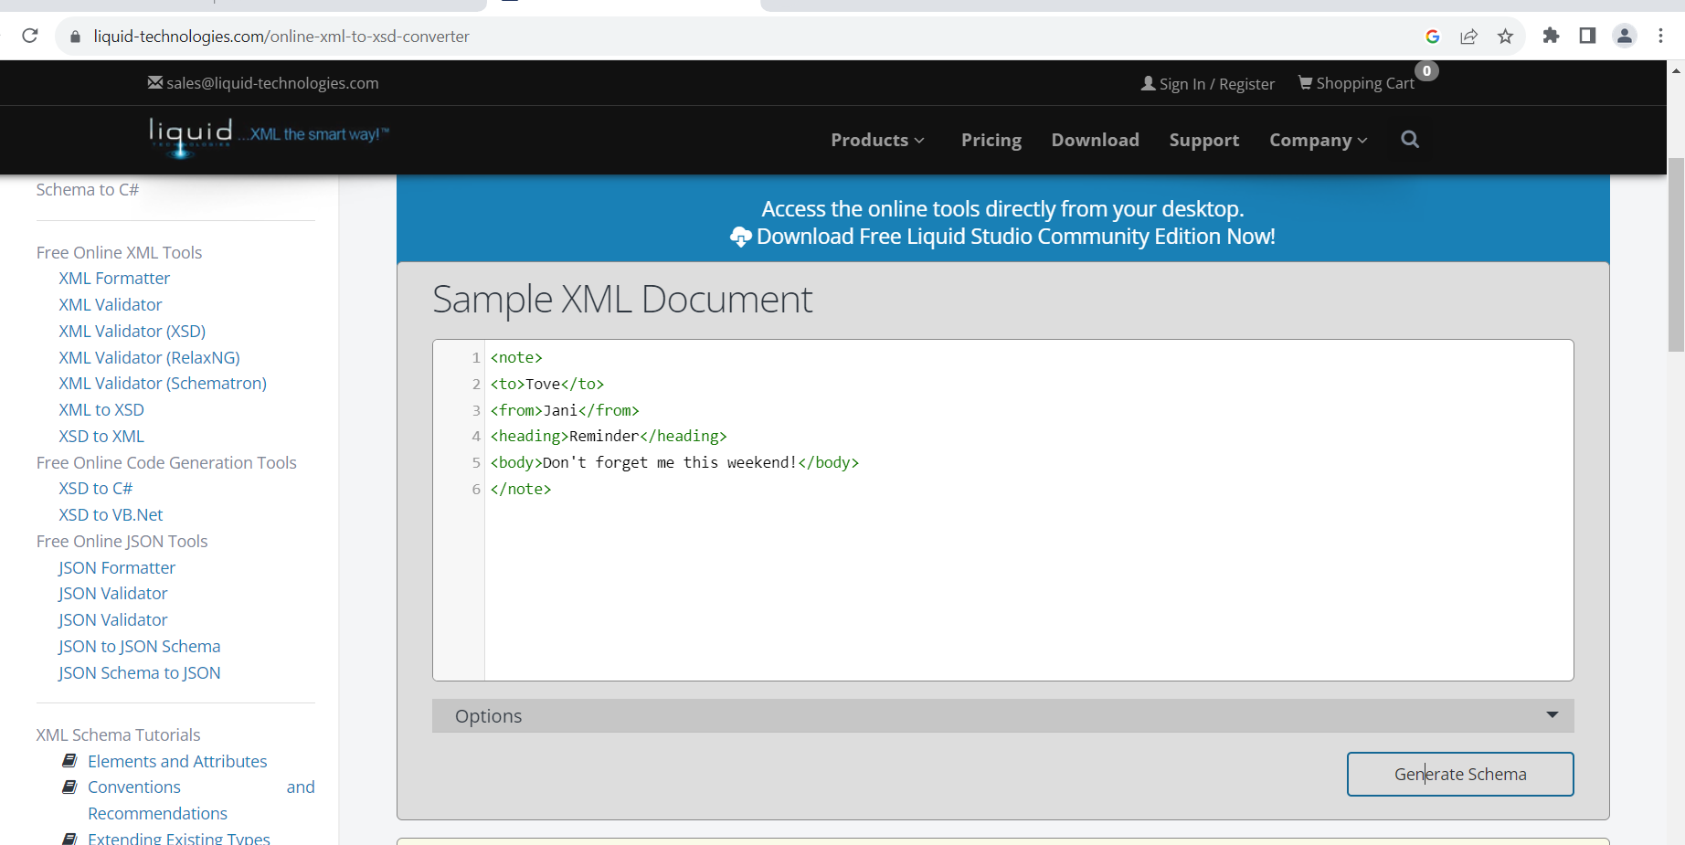

Saved in jmeter example folder with extension .xsd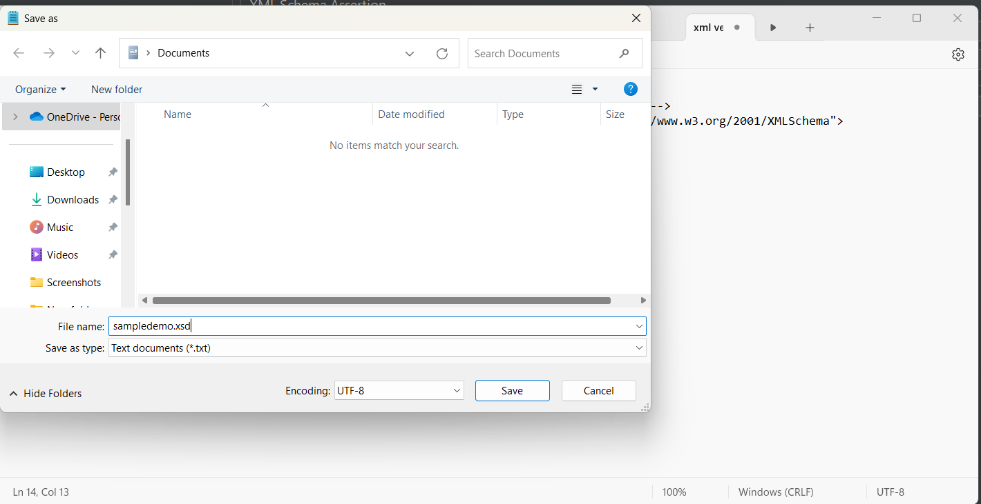

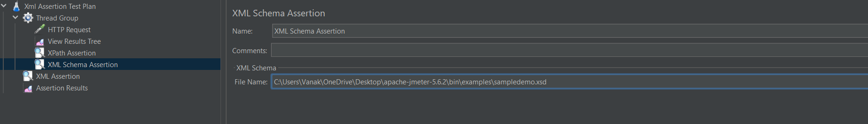

Click on run button

